Set kirim email

Password pakai “app password”

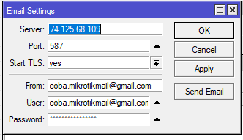

Netwatch script

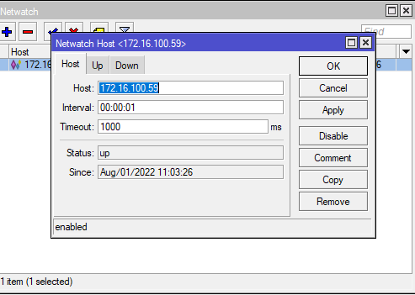

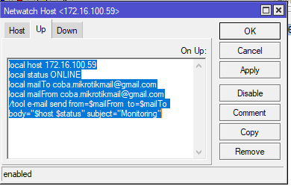

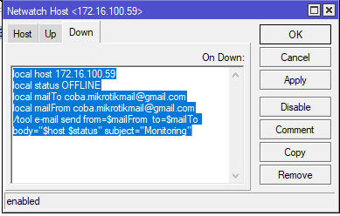

**Monitoring IP 10 digit**

local host 172.16.100.19

local status OFFLINE

local mailTo coba.mikrotikmail@gmail.com

local mailFrom coba.mikrotikmail@gmail.com

/tool e-mail send from=$mailFrom to=$mailTo body="$host" subject="$host $status"

**Monitoring IP 11 digit**

local host 172.16.100.192

local status ONLINE

local mailTo coba.mikrotikmail@gmail.com

local mailFrom coba.mikrotikmail@gmail.com

/tool e-mail send from=$mailFrom to=$mailTo body="$host" subject="$host $status"

